Enterprise Reporting & Automation Strategy Using Microsoft Tools
Company: RetailHub Pvt Ltd
BY: Tushar Dev Singh

Proposed Solution Overview
RetailHub currently relies on manual spreadsheet-based reporting, which leads to delays, data inconsistencies, and limited visibility into business operations. To modernize its reporting and automation capabilities, the organization can implement a solution using Microsoft Power Platform and SQL Server Reporting Services (SSRS).
The proposed solution integrates data from multiple systems such as sales transactions, inventory systems, customer orders, supplier databases, and finance systems into a centralized SQL Server database. This centralized data repository will act as the foundation for reporting and analytics.
SSRS will be used to generate structured operational reports such as financial statements, daily sales reports, and invoice reports. These reports require fixed formatting and scheduled delivery.
At the same time, Power BI will provide interactive dashboards that allow management to analyze sales trends, regional performance, and inventory levels in real time.
To improve operational efficiency, Power Apps can be used to create internal business applications for inventory tracking and operational management, while Power Automate will automate workflows such as purchase approvals and report notifications.
Additionally, Power Virtual Agents can be used to deploy a chatbot that helps customers track orders and receive automated responses to common queries.
Together, these Microsoft tools create an integrated ecosystem that enhances reporting capabilities, improves decision-making, reduces manual work, and enhances customer experience.

User Story 1 – Understanding the Current Reporting Challenges
As a Technology Consultant, I want to analyze the existing reporting process so that I can identify the major operational and data-related challenges faced by RetailHub.
Currently, RetailHub relies heavily on spreadsheets for reporting across different departments. Store managers receive sales reports manually, finance teams prepare monthly financial summaries through manual calculations, and inventory managers lack real-time visibility of stock levels.
These processes lead to several operational challenges:
- Manual reporting increases the risk of data errors and inconsistencies.
- Decision-making becomes slow due to delayed reporting.
- Employees spend excessive time collecting and compiling data from multiple systems.
- There is limited visibility into business performance across regions.
- Customer support teams must handle repetitive queries manually.
Replacing spreadsheet-based reporting with automated reporting tools can significantly improve operational efficiency.

User Story 2 – Business Intelligence for Management
As a Store Manager or Business Executive, I want to access interactive dashboards showing sales performance and business trends so that I can make data-driven decisions quickly.
Solution Using Power BI
Power BI dashboards can provide management with insights such as:
- Sales performance by store and region
- Monthly and quarterly revenue trends
- Product category performance
- Customer purchasing patterns
- Inventory availability across stores
Managers can interact with dashboards by applying filters, drilling down into specific regions, and identifying trends that influence business strategy.
This enables faster and more informed decision-making.
Implementation Demonstration
To demonstrate the proposed business intelligence solution, a Power BI dashboard was developed by connecting Power BI Desktop to the RetailHub SQL Server database. The dashboard provides interactive visualizations such as KPI cards, bar charts, pie charts, and geographic maps to analyze sales performance across different cities and product categories.
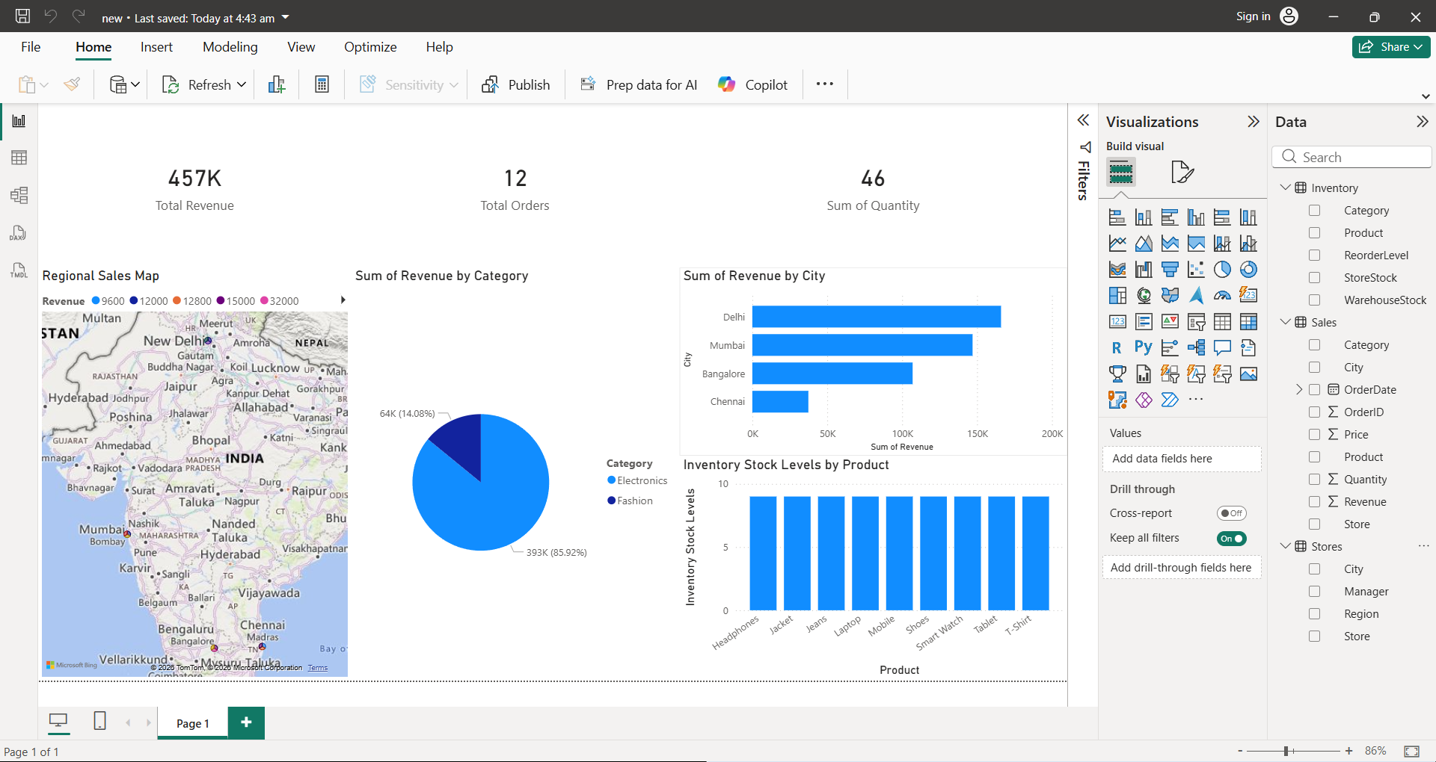

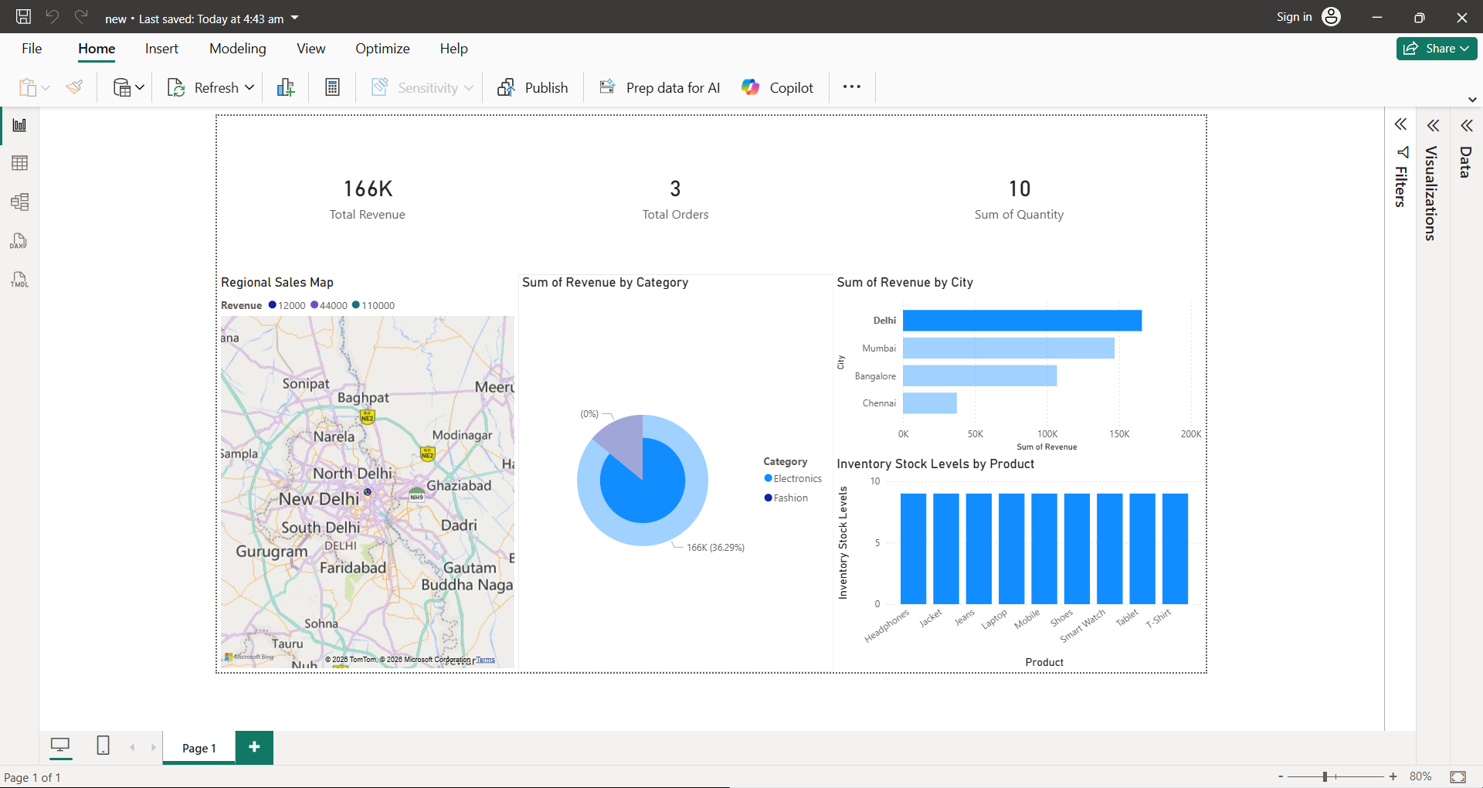
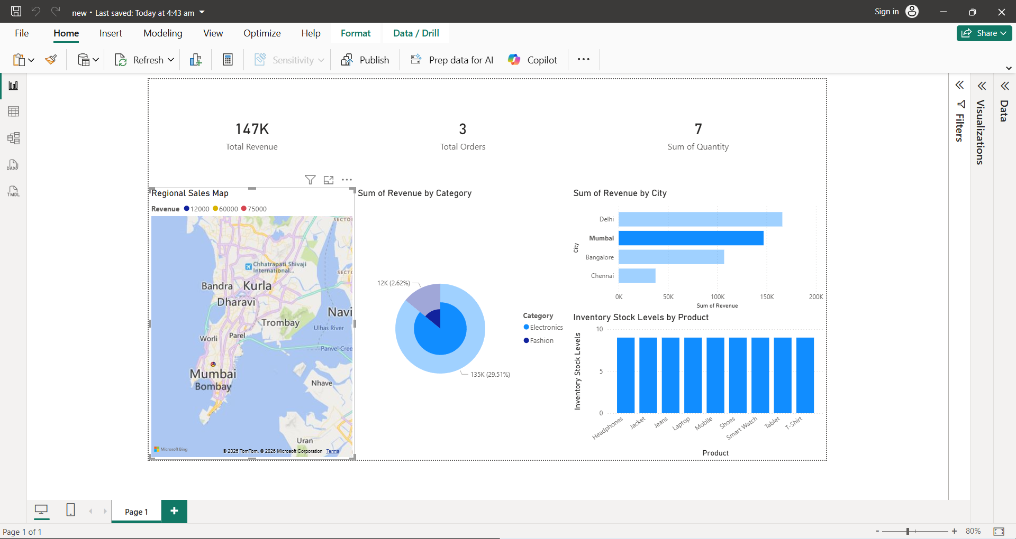

User Story 3 – Improving Internal Business Applications
As an Inventory Manager, I want a centralized application to manage inventory data so that I can monitor stock levels across stores and warehouses.
Solution Using Power Apps
Power Apps can be used to build an internal inventory management application that allows employees to:
- Update product stock levels
- Track inventory movement between warehouses and stores
- Manage supplier orders
- Monitor stock shortages
This application can be accessed through web browsers or mobile devices, allowing staff to update inventory information in real time.

User Story 4 – Automating Business Workflows
As an Operations Manager, I want repetitive operational tasks to be automated so that employees can focus on more strategic work.
Solution Using Power Automate
Power Automate can automate various workflows including:
- Approval workflows for purchase orders
- Automatic notifications for low inventory levels
- Scheduled report distribution
- Alerts for delayed shipments
Automation reduces manual work and improves operational efficiency.

User Story 5 – Enhancing Customer Support
As a Customer Support Manager, I want customers to receive automated responses for common queries so that support teams can focus on more complex issues.
Solution Using Power Virtual Agents
A chatbot can be implemented to assist customers with:
- Checking order status
- Tracking delivery updates
- Answering frequently asked questions
This reduces the workload of customer support agents and improves response time for customers.

User Story 6 – Generating Operational Reports
As a Finance Manager, I want standardized operational reports to monitor financial and operational performance.
Solution Using SSRS
SSRS will generate structured reports such as:
- Daily store sales reports
- Monthly financial statements
- Inventory summary reports
- Customer invoices and billing reports
These reports can be automatically scheduled and distributed to relevant stakeholders in formats such as PDF or Excel.
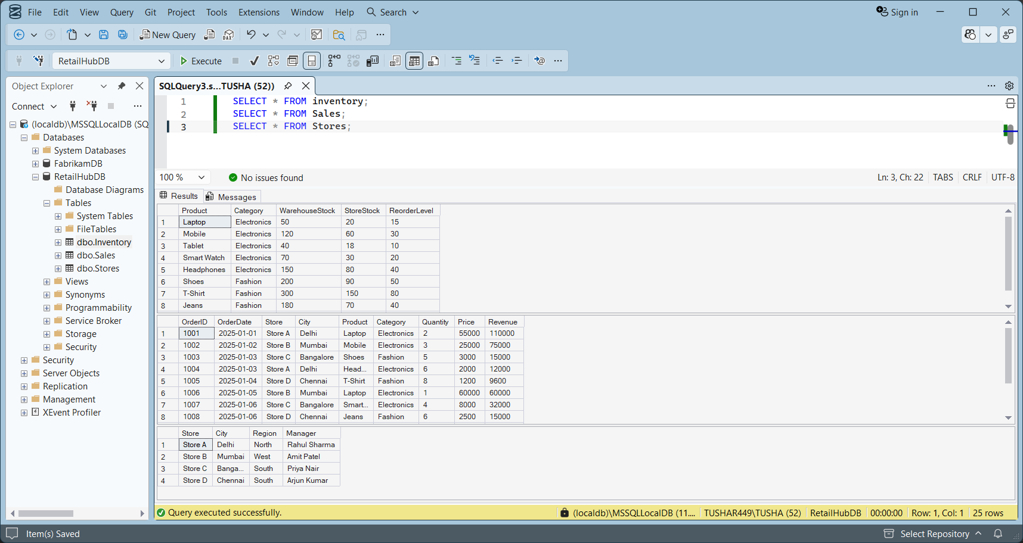

User Story 7 – Selecting the Appropriate Reporting Tool
As a Business Analyst, I want to understand when to use SSRS versus Power BI so that reporting tools are used effectively

Criteria | SSRS | Power BI
Reporting Type | Paginated reports | Interactive dashboards
Best Use Case | Financial and operational reports | Business analytics
Visualization | Basic charts and tables | Advanced visualizations
User Interaction | Limited | Highly interactive
Output | PDF, Excel, Print | Web dashboards

SSRS should be used for operational reporting, while Power BI is best suited for analytics and performance monitoring.

User Story 8 – Designing the System Architecture
As an IT Architect, I want to design a unified architecture integrating Microsoft reporting and automation tools so that data flows efficiently across the organization.
Architecture Flow
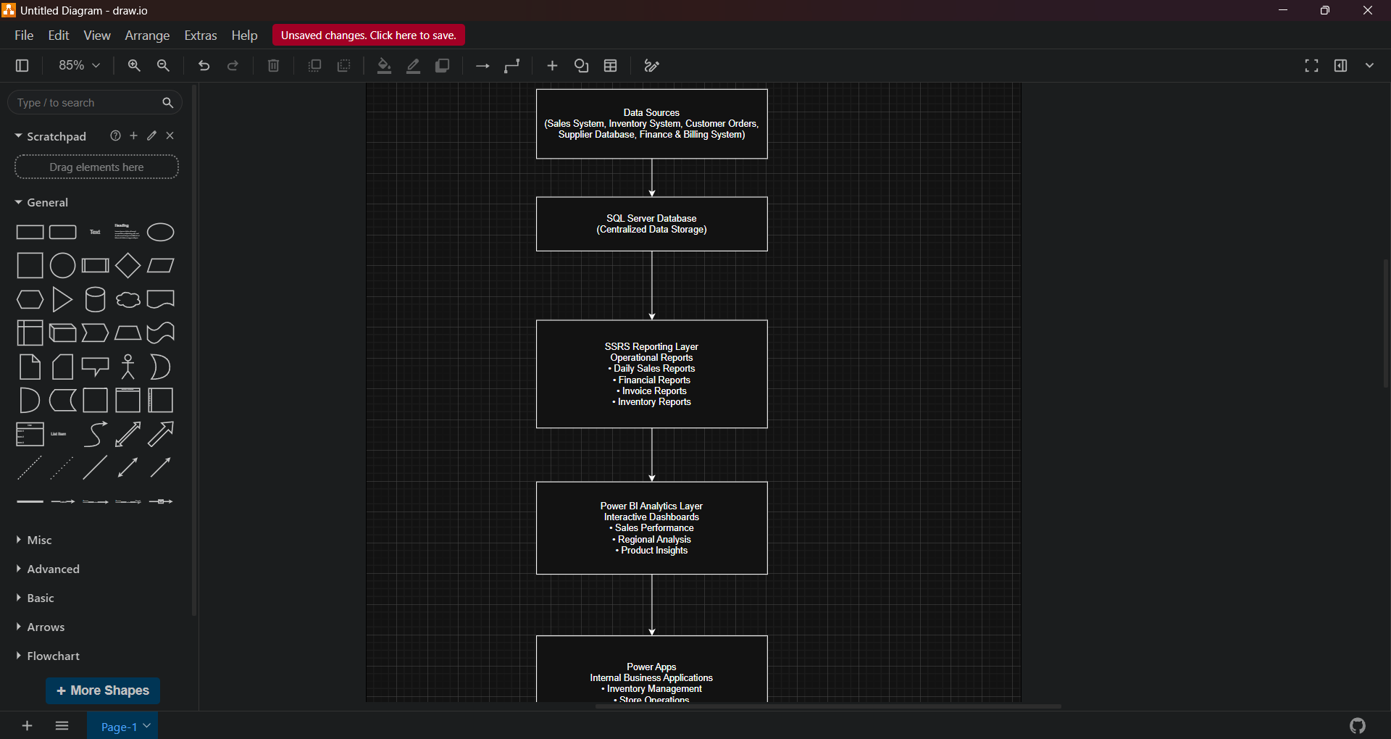
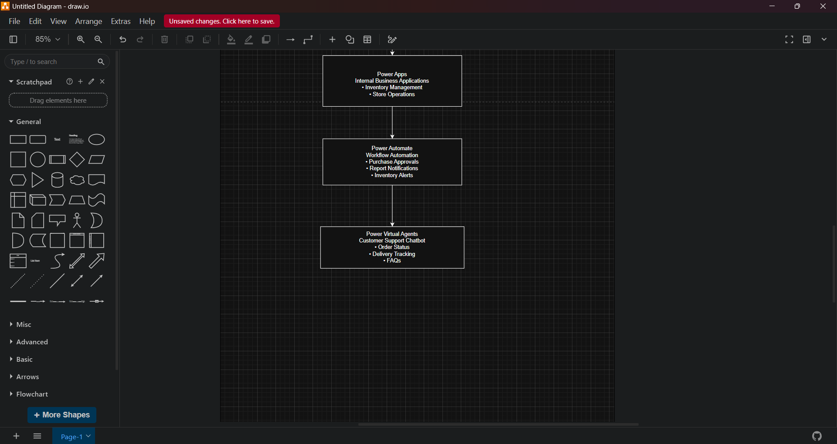

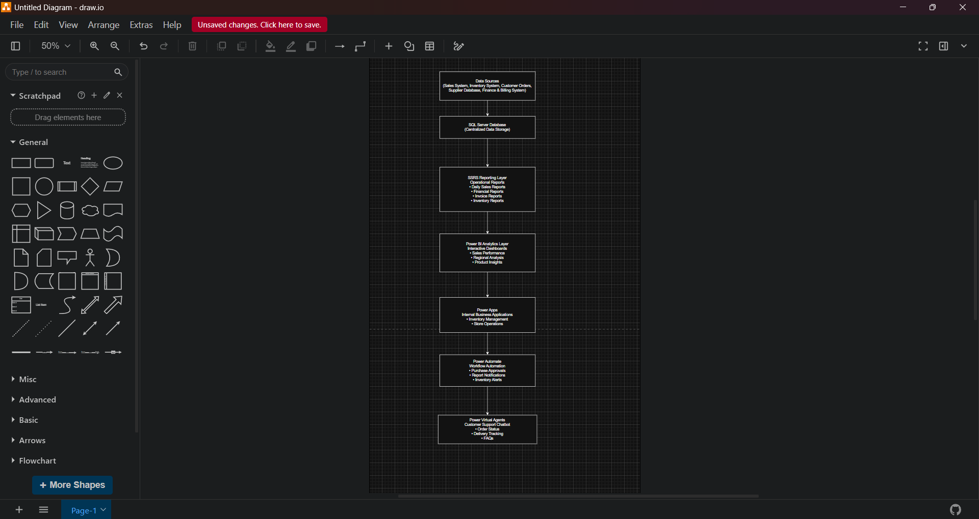

Final Reflection
Using Microsoft Power Platform together with SQL Server Reporting Services provides a comprehensive solution for modern organizations. SSRS handles structured operational reporting, while Power BI provides interactive analytics and dashboards for management. Power Apps enables organizations to build custom business applications without complex development, and Power Automate helps streamline workflows by automating repetitive tasks. Power Virtual Agents improves customer experience through automated support. This integrated approach improves operational efficiency, reduces manual processes, and provides real-time insights that help organizations make better business decisions.

